**Report on general government budget**

**February 2020**

General government budget recorded a deficit of **RON 8.3 billion (0.73% of GDP)** in the first two months of 2020 (Annexes 1 and 2).

Compared to the same period of last year, the deficit in Jan - Feb 2020 is mainly explained by: (i) higher VAT reimbursements by RON 0.73 billion - RON 3.22 billion in 2020 compared to RON 2.49 billion in 2019, (ii) higher investment by ~RON 1.63 billion, and (iii) RON 1.29 billion payments in advance for the transitional national aid in the vegetal and zootechnical sector.

1. **general government revenue**

Total revenue amounted to RON 51.28 billion in the first two months of 2020, increasing by 9.8% compared to the level recorded in the same period last year. This is mainly due to a significant rise of budget revenues in February (by 13.6% yoy). In terms of revenue`s structure, the most important categories - the tax on wages, VAT, excise duties on energy products, social insurance contributions - registered a significant acceleration in February.

As a share of GDP, the budget revenues recorded only a marginal increase (0.1 pp).

***Personal*** ***income tax*** receipts amounted to RON 4.24 billion in the first two months of 2020 and grew by 16.2% (yoy).

The pace of the labour income tax receipts in the first two months (10.1% yoy) mainly reflects the dynamics of the wage bill in the economy in Dec 19 – Jan 20 (10.2%, reflecting a 9.3% growth of average gross earnings and a 0.9% rise in employment). At the same time, one notes an acceleration of the monthly labour income tax receipts, from 5% at the end of last year, to 8% and respectively 13% in the first two months of 2020, although the growth rate of the average gross earnings has slowed steadily in recent months. In addition, compared to the similar period of last year, exempting the wages in construction and related industrial sectors from the labour income tax generated a negative impact on the revenue in January 2020[1].

With regard to the other categories of income taxes, significant increases were recorded in dividend income receipts (38.3%) and pension income receipts (42.8%), since the pension point increased as of September 1st, 2019.

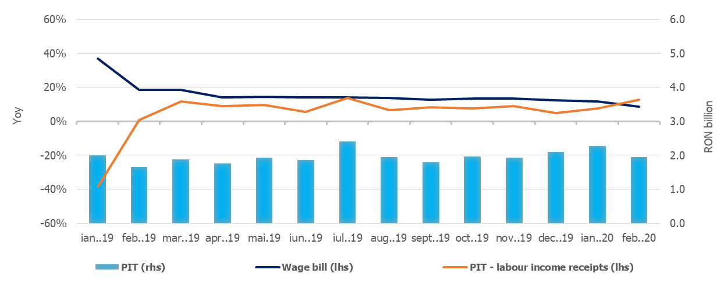

Source: MoPF, NIS, own calculations

**Fig.1 Personal Income Tax Revenue**

***Social contributions*** revenue amounted to RON 19.56 billion in the first two months, rising by 11.2% yoy. Similar to the evolution of the wage tax revenue, the social contributions receipts accelerated from a growth rate of 8.5% in December 2019 to 10.0% in January and 12.5% in February 2020 (yoy). Compared to the same period last year, social contributions were negatively influenced: (i) in January 2020 by exempting employees in construction and related industrial sectors from health insurance contribution, as well as by reducing the social contributions due by employers (according to GEO No. 114/2018); (ii) in February 2020 as a result of the change in the tax base for social insurance and health insurance due by part-time employees (negative impact of about RON 82 million).

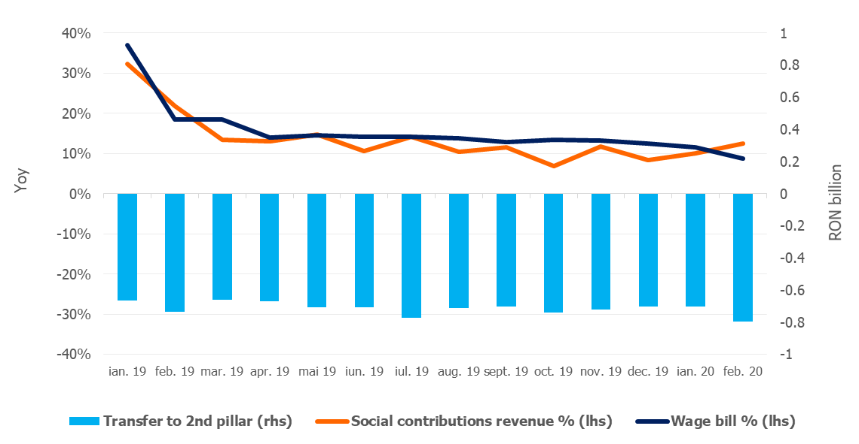

Source: MoPF, NIS, own calculations

**Fig.2 Social contribution revenue**

***VAT*** receipts amounted to RON 11.52 billion in the first two months of 2020, increasing by 6.7% yoy.

During the analysed period, gross VAT revenues (excluding reimbursements), grew by 11.4%, yoy (12.2% in February), in line with the dynamics of the relevant macroeconomic base – the turnover in trade, services and industry - 11% yoy. Also, VAT reimbursements were 29.4% higher than last year (RON 3.2 billion in January-February 2020, compared to RON 2.5 billion in January-February 2019).

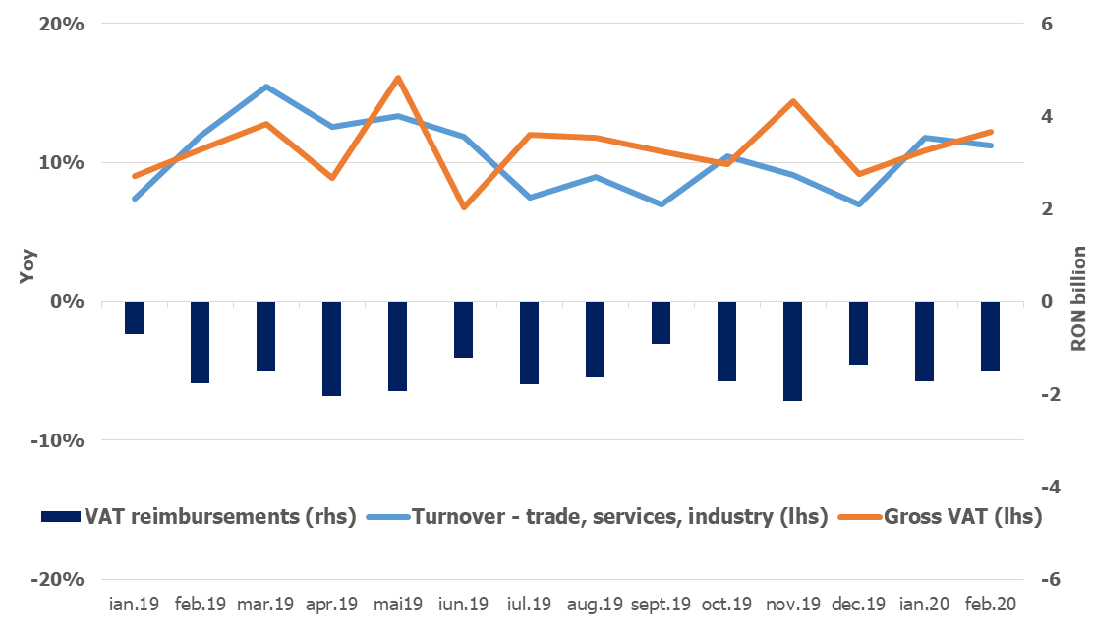

Source: MoPF, NIS, own calculations

**Fig.3 VAT revenue**

***Excise duties*** receipts amounted to RON 5.03 billion, advancing by 11.3% compared to the first two months of 2019.

Excise revenue from energy products expanded in February by 12.7%, yoy (+10.8% in Jan-Feb), despite the reduction in excise level on fuel since the beginning of the year (by 13% for gasoline and 14.3% for diesel). Excise revenue from tobacco products was 11.4% higher compared to January-February 2019, supported by a 4.2% hike in the excise level for cigarettes.

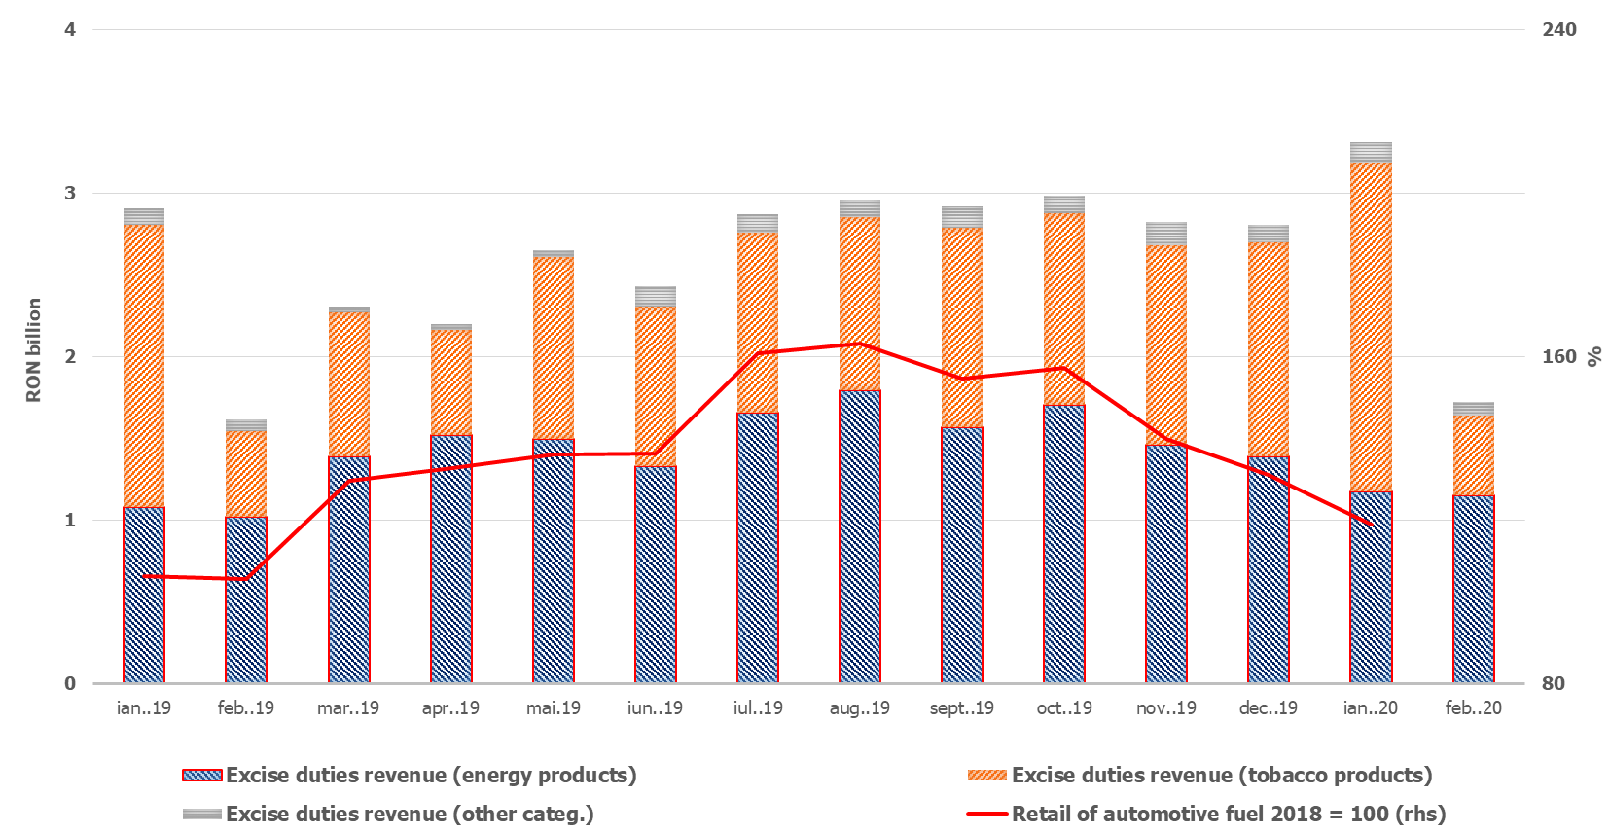

Source: MoPF, NIS, own calculation

**Fig.4 Excise duties revenue**

Revenue from ***taxes on use of goods*** totalled RON 0.72 billion, advancing by 24,6% (yoy). This dynamic was mainly due to an increase in revenues from gambling taxes by 45,4% yoy.

***Non-tax revenue*** amounted to RON 3.74 billion in the first two months of the current year, rising by 9,4% (yoy). This increase was backed by higher revenue from sale of greenhouse gas emission certificates (+21,6%, yoy) and interest income (+154,3%, yoy). However, the positive dynamics of these revenues was mitigated by the NBR's net revenues payment made in February 2020, which decreased by 34.5% compared to February 2019.

***EU Refunds and donations*** totalled RON 2,4 billion in January and February, rising by 2.7% compared to the corresponding period of 2019.

1. **GENERAL GOVERNMENT EXPENDITURE**

General government expenditure totalled RON 59.58 billion (5.2% of GDP), advancing by 14,8% compared to the same period of 2019. Total expenditure increased by 0.3 pp, from 4.9% of GDP in 2019 to 5.2% of GDP in 2020.

***Compensation of employees*** amounted toRON 17.32 billion, up 9.9% (yoy). This increase is mainly explained by public wages hikes and introduction of meal allowance to all public sector employees as of January 1st, 2019 (according to Law 153/2017), but also by another round of public wages hikes as of January 1st, 2020. Compensation of employees maintained its share to GDP at 1.5%.

***Goods and services expenditure*** expanded by 13.9% compared to the corresponding period of 2019, reaching RON 7.47 billion. A larger increase was recorded at local budgets level, as well as at the health social security fund budget (higher payments for drugs and outpatient medical services).

***Social assistance expenditure*** reached RON 22.18 billion, advancing by 16% (yoy). This dynamic is mainly explained by the increase of the pension point by 15% as of September 1st, 2019 (from RON 1,100 to RON 1,265); the increase of the social allowance for pensioners by 10%; of child allowance as of May 1st, 2019 and, as well as indexing child allowance with the inflation rate in 2019, as of January 1st, 2020. Also, social assistance expenditures include the advance payments of RON 1.4 billion relating to 50% of February pension expenditure distributed by Romanian Postal Service.

***Subsidies*** reached RON 1,994.3 million, more than 2.5 times higher compared to the same period of 2019. This dynamic was mainly determined by subsidies in the agricultural sector, and by advance payments for the transitional national aid in the vegetal and zootechnical sector.

***Other transfers*** totalled RON 3.1 billion, decreasing by 12,3% compared to the corresponding period of 2019.

***Other expenditure*** amounted to RON 0.86 billion (this category includes mainly payment titles issued by the National Authority for Properties Restitution, scholarships for students and payments related to court decisions).

***Expenditure for projects financed from non-reimbursable external funds*** (including EU subsidies for agriculture) reached RON 2.79 billion, 8.7% above the level recorded in the first two months of 2019.

***Investment***, which includes capital expenditure and spending related to development programs financed from domestic and external sources, amounted to RON 3.2 billion, more than double compared to the first two months of 2019 (reflecting increases at both central and local level, financed from both domestic and non-reimbursable external funds). 

Source: MoPF

**Fig. 5 Public investment structure**







1. In January 2019, the receipts were not affected by any exemption from income tax payment. In December 2019, more than 500,000 employees in the field of construction and related sectors were exempted from paying income tax.