**Report on general government budget**

**January 2020**

General government budget recorded a deficit of **RON 0,46 billion (0,04% of GDP)** in January 2020 (Annexes 1 and 2).

Compared to the surplus reached in the same month of last year, the deficit in January 2020 is mainly explained by the increase of VAT reimbursements by RON 1 billion (RON 1.72 billion in January 2020, compared to RON 0.72 billion in January 2019), as well as growing investment spending by approximately RON 0.82 billion.

1. **general government revenue**

Total revenue amounted to RON 27.55 billion in January 2020, 6.8% above the level reached in the same month last year.

As a share of GDP, the budget revenue recorded only a marginal decrease (0.1 pp), mainly due to the increase of VAT reimbursements by 141%.

***Personal*** ***income tax*** receipts[1] amounted to RON 2.28 billion in January 2020 and grew by 14,4% (yoy).

The pace of the labour income tax receipts (8%, yoy) largely reflects the advance of average gross earnings (10.7%) and employment (0.9%) recorded in December 2019. Nevertheless, exempting the wages from construction and related industrial sectors (according to GEO no. 114/2018) from the labour income tax lowered the revenue by RON 127.9 million[2].

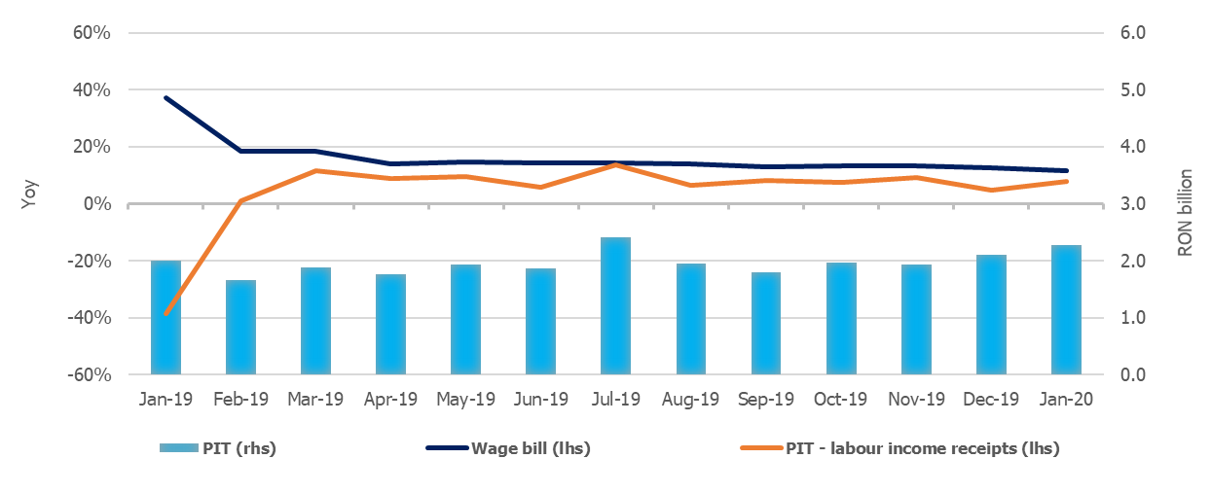

Source: MoPF, NIS, own calculations

**Fig.1 Personal income tax revenue**

***Social contributions*** revenue amounted to RON 9.97 billion in January, accelerating from 8.5% in December 2019 to 10% in January 2020 (yoy). Social contributions receipts largely reflect developments in the economy's wage bill (11.6% in December 2019, slowing from the previous month). Furthermore, the receipts were adversely affected by exempting construction employees and related industrial sectors from the health insurance contribution, as well as by reducing the social contributions due by employers (according to GEO no.114/2018, with a negative impact of RON 180.9 million).

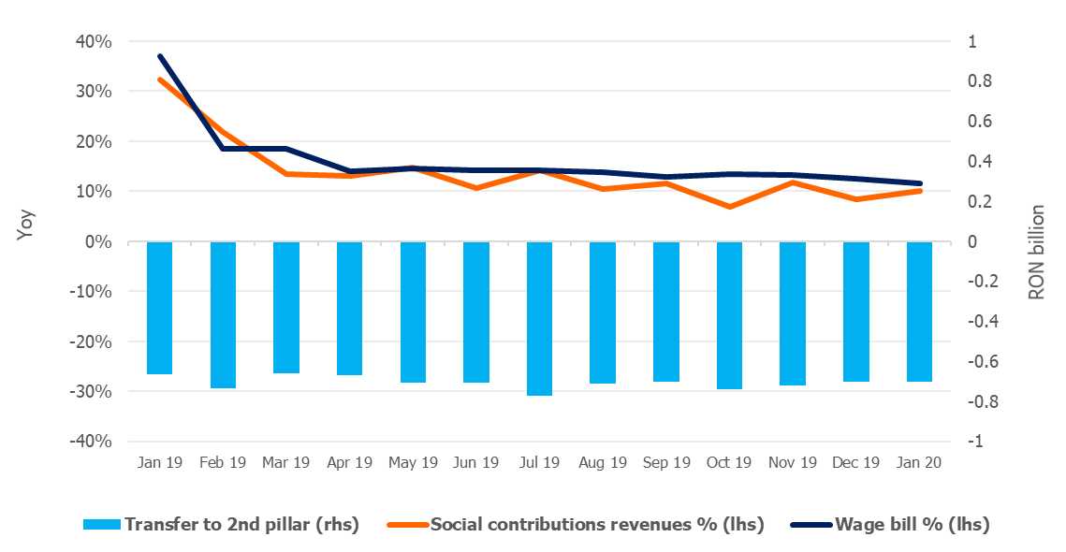

Source: MoPF, NIS, own calculations

**Fig.2 Social contribution revenue**

***VAT*** receipts amounted to RON 6.68 billion in January 2020, 4% lower (yoy). The decline in net VAT receipts is explained by the increase of VAT reimbursements by 141% in January 2020 (RON 1.72 billion in January 2020, compared to RON 0.72 billion in January 2019)[3]. Moreover, gross VAT revenue (excluding reimbursements) grew by 11% yoy (recording a historical record level of RON 8.4 billion), in line with the relevant macroeconomic base developments - turnover in trade, services and industry (12%, yoy).

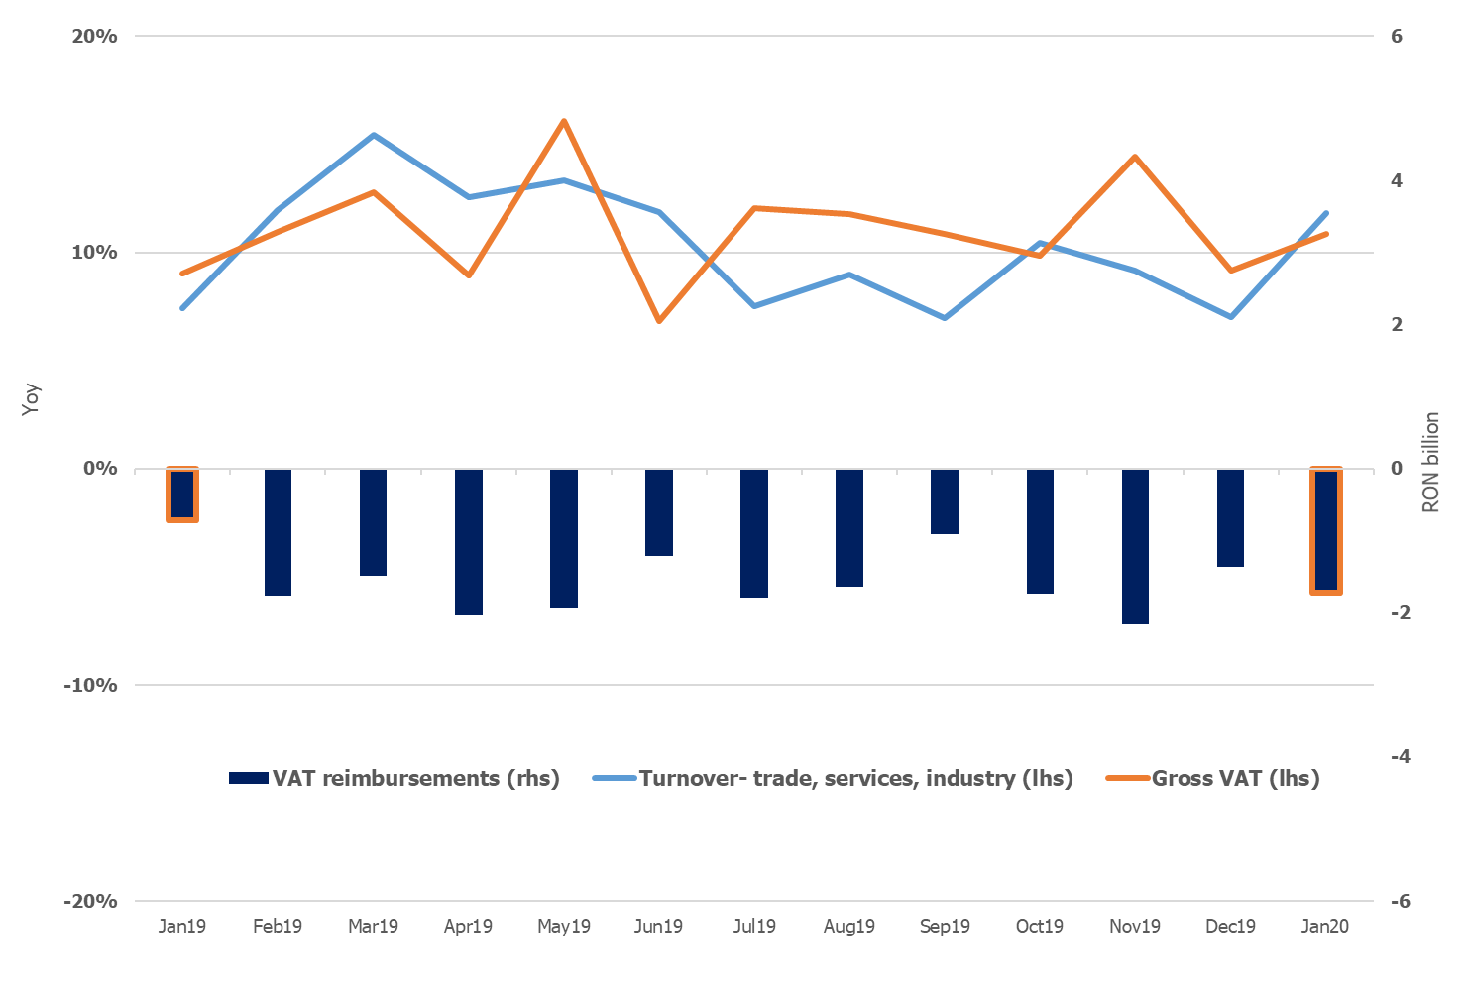

Source: MoPF, NIS, own calculations

**Fig.3 VAT revenue**

***Excise duties*** receipts amounted to RON 3.31 billion, advancing by 13.9% compared to January 2019, following the good performance recorded in November and December 2019 (16.2% on average, yoy).

Excise revenue from energy products expanded by 9% (yoy), while the excise level on fuel was cut by 13% (gasoline) and by 14,3% (diesel). Excise revenue from tobacco products was 16.8% larger compared to January 2019, supported by the hike of 4.2% in the excise level for cigarettes. Monthly revenues from excises are more volatile due to both tax warehousing policy of suppliers and consumption.

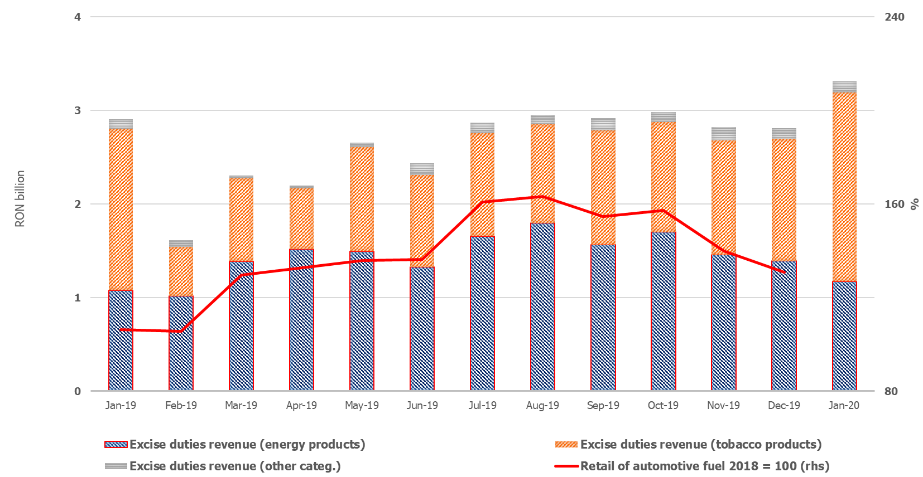

Source: MoPF, NIS, own calculations

**Fig.4 Excise duties revenue**

Revenue from ***taxes on use of goods*** amounted to RON 0.36 billion, advancing by 25,3% (yoy) mainly due to the 47.9% increase in revenues from gambling taxes.

***Non-tax revenue*** totalled RON 2.11 billion in January 2020 and grew by 11,6% (yoy). This dynamic was backed by increasing revenue from sale of greenhouse gas emission certificates (+113.7%) and interest income (+17.4%).

***EU Refunds and donations*** amounted to RON 1.11 billion in January 2020 and stood at 0.1% of GDP.

1. **GENERAL GOVERNMENT EXPENDITURE**

General government expenditure totalled RON 28 billion (2.5% of GDP), advancing by 11.6% compared to January 2019. Total expenditure increased marginally by 0.07 pp, from 2.4% of GDP in 2019 to 2.5% of GDP in 2020.

***Compensation of employees*** amounted toRON 8.46 billion, up 11.9% (yoy). This outcome is mainly explained by the hikes in public wages and the introduction of meal allowance to all public sector employees as of January 1st 2019 (according to Law 153/2017). As a percentage of GDP, compensation of employees stood at 0.7%.

***Goods and services expenditure*** expanded by 2.8% (yoy), reaching RON 3.23 billion, following the increase in local administration expenses and the postal service payment (related to pensions distribution).

***Social assistance expenditure*** reached RON 11.87 billion, advancing by 15.1% (yoy). This dynamic is mainly explained by increases in: (i) pension point by 15% as of September 1st 2019 (from RON 1.000 to RON 1.265); (ii) social allowance for pensioners by 10%, (iii) child allowance increase as of May 1st 2019 and, (iv) advance payments of 1.4 billion lei relating to 50% of February pension expenditure distributed by Romanian Postal Service.

***Other transfers*** amounted to RON 1.7 billion, growing by 21.0% (yoy), reflecting a higher national contribution to the EU budget (RON 1.5 billion in January 2020 compared to RON 1.2 billion in January 2019).

***Other expenditure,*** including payment titles issued by the National Authority for Properties Restitution (RON 0.2 billion), scholarships for students and court decisions, amounted to RON 0.49 billion and advanced by 23% (yoy).

Expenditure for projects financed from non-reimbursable external funds (including EU subsidies for agriculture) reached RON 1.26 billion, 2.8% above the level reached in January 2019.

***Investment***, which includes capital expenditure and spending related to development programs financed from domestic and external sources, amounted to RON 1.31 billion and has been three times higher compared to January 2019 (reflecting increases at both central and local level, as well as from both domestic and non-reimbursable external funds).

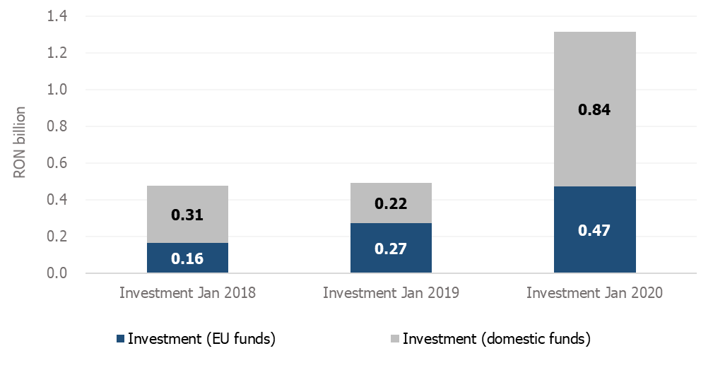

Source: MoPF

**Fig. 5 Public investment structure**







1. PIT revenue includes tax receipts from labour income, capital income and other sources (mostly pensions).
2. Receipts from January 2019 were not affected by this exemption, as they were related to the wages of December 2018. In December 2019 more than 500,000 construction employees have benefited from this exemption.
3. The decrease is also explained, to a certain extent, by the broadening of the 5% reduced VAT rate to restaurant and catering services, high quality food deliveries, hotel accommodation services (from 9%) starting with January 1, 2019 (affecting receipts since February 2019).